
JENSON
UPHOLSTERY
RANGE
3STR + FOOTSTOOL

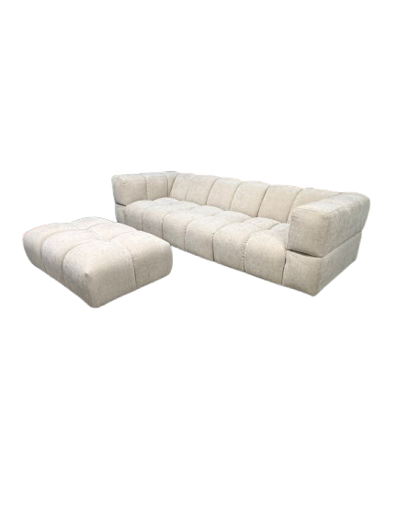
Estimated assembly time: 30 minutes (2 people)

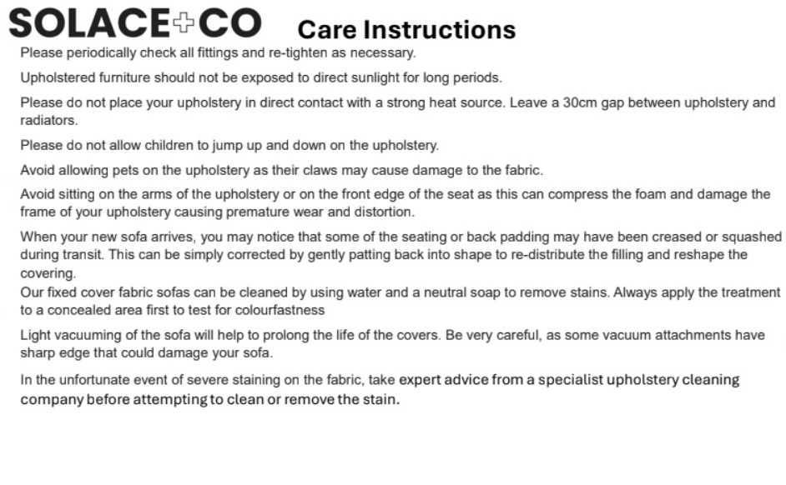
Step by step Assembly Instructions

TOOLS REQUIRED PART LIST
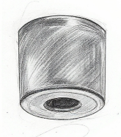
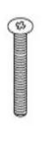
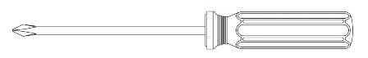

POZIDRIV SCREWDRIVER X 1 PLASTIC LEGS X 16 SCREWS X 16

FITTING LEGS INSTRUCTION
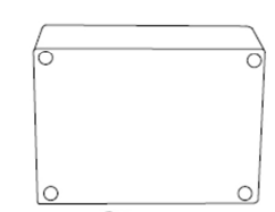
1. Spread the removed packing material on the floor to damage to the unit.
2. Place the unit on its back on the packing material.
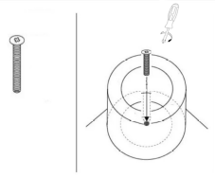
3. At the corners of unit locate the pilot holes for the leg fixing screw.
4. Align the legs with the individual pilot holes.
5. Insert a screw supplied through the hole in the leg and into the pilot hole.
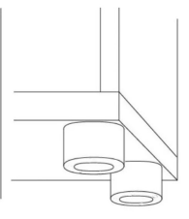
6. Tighten the screws with a pozidrive screwdriver, see image below.
7. Carefully turn the unit over without dropping it so the legs are on the floor
8. Carefully lift and carry the unit into its location,
DO NOT DRAG!

Join your elements together using the spring loaded latches.
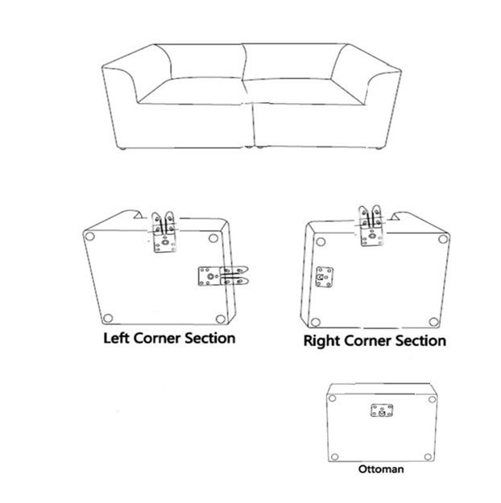
Position your elements as you want it configured, leaving a 1-foot gap between each piece. Feel along the bottom and pull out the latches on each side.

Step 1: Pull out the latch.
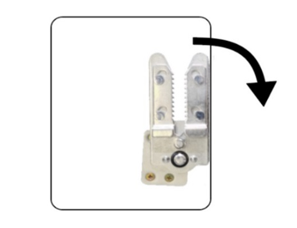

Step 2: Line up the latch with the adjacent catch bracket.
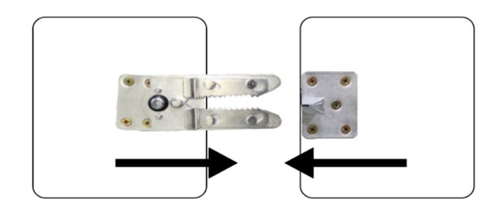

Step 3: Push the two furniture elements together, listening for a clicking sound, until the two pieces are touching.
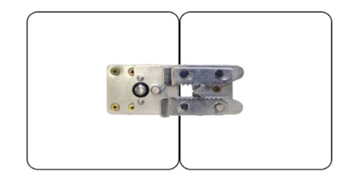

Step 4: If your unit doesn’t include a Right corner section, remove the pull out bracket from the Middle section.
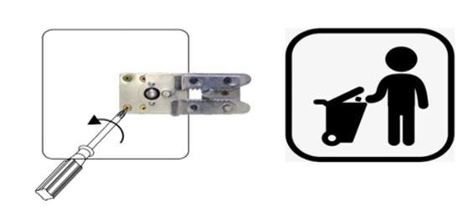

If you want to move your unit.
To separate the pieces lift the Right hand unit to release the brackets.
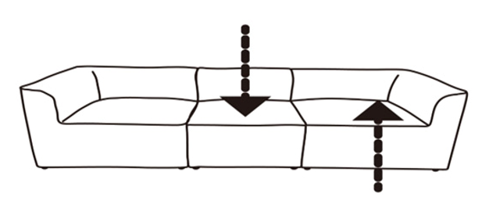
Storing separate elements safely.
Turn the latches so that they fully under the furniture piece.
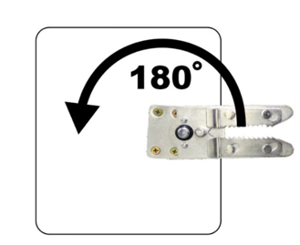

FOR PARTS & TECHNICAL SUPPORT VISIT:  Telephone:  01924950108  Email Address:  support@bedkingdom.co.uk | Manufacturer  Flair Furnishings Ltd t/a Bedkingdom,  Old Delivery Office, Oldfield Lane,  Heckmondwike, England, WF16 0JD  Support@bedkingdom.co.uk  01924 950108 | EU Responsible (for authorities only)  eucomply OÜ  Pärnu mnt 139b-14  11317 Tallinn, Estonia  hello@eucompliancepartner.com  +3375690241

